

SSR COLLEGE OF ARTS, COMMERCE & SCIENCE

SILVASSA

(Affiliated to Savitribai Phule Pune University, NAAC Accredited with B+ Grade)

Submitted to the partial fulfillment of

# T.Y BBA (CA)

2022-2023

Project Work

## “MOVIE TICKET BOOKING”

Guided By: Submitted By:

Mr. Vishal Langaliya Mr. Shivam Singh

Mr. Souravdeep Singh



SSR COLLEGE OF ARTS, COMMERCE & SCIENCE

SILVASSA

(Affiliated to Savitribai Phule Pune University, NAAC Accredited with B+ Grade)

Sayli, Silvassa-396230, D&N.H

Department of Computer Application

# CERTIFICATE

This is to certify that Mr. Shivam Singh of T.Y.B.B.A [Computer Application] has successfully completed his/her project work on the topic “**MOVIE TICKET BOOKING**” in the academic year 2022-2023.

Project Guide H.O.D

Internal Examiner External Examiner

SEAL OF THE COLLEGE



__________________________________________________________________________________

SSR COLLEGE OF ARTS, COMMERCE & SCIENCE

SILVASSA

(Affiliated to Savitribai Phule Pune University, NAAC Accredited with B+Grade)

Sayli, Silvassa-396230, D&N.H

Department of Computer Application

# CERTIFICATE

This is to certify that Mr. Souravdeep Singh of T.Y.B.B.A [ComputerApplication] has successfully completed his/her project work on the topic “**MOVIE TICKET BOOKING**” in the academic year 2022-2023.

Project Guide H.O.D

Internal Examiner External Examiner

Seal of the College

**ACKNOWLEDGEMENT.**

It is a great pleasure to acknowledge and express our deep sense of gratitude to SSR College of ARTS COMMERCE & SCIENCE for providing me the infrastructure to carry out the project.

We extremely grateful and remain indebted to our guide by Mr. VISHAL LANGALIYA for being a source of inspiration and for his constant support in the Design, Implementation and Evaluation of the project. We are thankful to him, for his constant constructive criticism and valuable suggestions, which benefited us a lot while developing the project on “**MOVIE TICKET BOOKING**.”

He has been a constant source of inspiration and motivation which helped us to complete this project successfully. Also extend my gratitude to our teachers and other staff members of the department for their constant support for completing this project. I would like to thank Savitribai Phule Pune University for providing us an opportunity to apply our knowledge and skills in a practical environment as a part of curriculum for T.Y.B.B.A [Computer Application].

Lastly but significantly, we express sincere gratitude to all our friends and fellow students at SSR College for their help and timely advice on various occasions during this project.

**ABSTRACT**

The Movie Ticket Booking System facilitates the users to enquire about the

recent movies available movies, booking and cancellation of movie tickets according

to theatre type and class type, enquire about the status of the booked tickets, etc.

The aim of this project is to design a website that gives an easy platform for

people to get details of trending films and to get movie tickets in the

easiest possible way making it simple for all to buy tickets from anytime

and anywhere.

This project contains introduction to movie ticket booking system. It is

computerized way of reserving the seats of movie in advanced. This online movie ticket

booking system can make the process of booking movie tickets much easier than ever

before. Then this project contains entity relationship model diagram based on movie

ticket booking system an introduction to relational model also example of some sq|

queries to retrieve data from the database of this system.

**Technologies Used:**

* Microsoft visual studio.
* MySQL server (Wamp).

**Server Requirement:**

* PHP version 8.2.
* MySQL (6.1+) MYSQL (6.1+), MySQL • Mb string PHP Extension.

**INDEX.**

|  |  |  |
| --- | --- | --- |
| **S.NO.** | **TOPIC** | **PAGE.NO** |
| **1.** | **INTRODUCTION**  1.Introduction to System  2.Scope Of the System | **6-8** |
| **2.** | **TOOL INFORMATION**  1.Front End Tool  2.Back End Tool | **9-12** |
| **3.** | **ANALYSIS**  1.Feasibility Study  2.Fact Finding Technique | **13-16** |
| **4.** | **SOFTWARE AND HARDWARE ARE REQUIREMENT** | **17-18** |
| **5.** | **SYSTEM DESIGN**  1.DFD  2.USE ER DIAGRAM  3.DATA DICTIONARY | **19-27** |
| **6.** | **INPUT AND OUTPUT DESIGN**  1.Screenshots | **28-35** |
| **7** | **ADVANTAGES AND LIMITAIONS** | **36-37** |
| **8.** | **FUTURE ENHANCEMENT** | **38-39** |
| **9.** | **BIBLIOGRAPHY** | **40-41** |

**1. INTRODUCTION**

## INTRODUCTION TO SYSTEM

Database is an organized collection of data. The data is typically organized to model aspects of reality in a way that supports processes requiring information. A DBMS makes it possible for end users to create, read, update and delete data in a database.

The DBMS essentially serves as an interface between the database and end users or application programs, ensuring that data is consistently organized and remains easily accessible. The DBMS manages three important Things: the data, the database engine that allows data to be accessed, locked or modified and the database schema, which defines the database’s logical structure.

These three foundational elements help provide concurrency, security , data integrity and uniform administration procedures. The DBMS can offer both logical and physical data independence. That means it can protect users and applications from needing to know where data is stored or having to be concerned about changes to the physical structure of data.

The main purpose of maintaining a database for Movie Ticket Booking System is to reduce the manual errors involved in the bookings and cancellation of tickets and make it convenient for the customers and the providers to maintain the data about their customers and also about the seats available at them.

Due to automation many loopholes that exist in the manual maintenance of the records can be removed. The speed of obtaining and processing the data will be fast. For future expansion the proposed system can be web enabled so that clients can make various enquiries about movie ticket booking. Due to this, sometimes a lot of problems occur and they are facing many disputes with the customers. To solve the above problem, we design a database which include**s** customer details, availability of movie seats, etc

### 1.2.Scope Of the System

This project is about creating a webapp for movie ticket booking system. The movie ticket booking system allows the user to do enquiry and get information about the trending movies and get to know about availability of seats for that movie according to theatre type, class type etc.

This website will provide users an easy way for booking and cancellation of movie tickets, enquire about the status of booked tickets, provide feedback about the system, etc. Also, in this ticket booking webapp all types of payment methods are accepted. There is a feedback form also in this webapp through which users can express their views openly to us about our system and give their valuable suggestion about the system functioning.

Also,there is an admin dashboard through which the system providers can keep track of functioning of the system. Through this admin dashboard system providers can see bookings of all movies and make new entries of movies according to new releases and edit data also delete booking in some cases.

Also, through this admin dashboard system providers keep track of the number of bookings and also, maintains user feedback given by users of this system. Also, through this admin dashboard system providers keep track of recent releases of movies and provide the same information to the users and also keep track of recent booking of the users.

Also, at the end of payment users get e-ticket containing details about the movie time, theatre type, class type etc.

## 2.TOOL INFORMATION

**2.1 FRONT END TOOL**

**HTML**: It istext (often with embeds such as images, too) that is organized in order to connect related items a style guide for typesetting anything to be printed in hardcopy or soft copy format a language that a computer system understands and uses to interpret commands.

HTML determines the structure of web pages. This structure alone is not enough to make a web page look good and interactive. So you'll use assisted technologies such as CSS and JavaScript to make your HTML beautiful and add interactivity, respectively.

**CSS:** CSS stands for Cascading Style Sheets CSS describes how HTML elements are to be displayed on screen, paper, or in other media CSS saves a lot of work. It can control the layout of multiple web pages all at once External stylesheets are stored in CSS files CSS can be used for very basic document text styling — for example, for changing the [colour](https://developer.mozilla.org/en-US/docs/Web/CSS/color_value) and [size](https://developer.mozilla.org/en-US/docs/Web/CSS/font-size) of headings and links. It can be used to create a layout — for example, [turning a single column of text into a layout](https://developer.mozilla.org/en-US/docs/Web/CSS/Layout_cookbook/Column_layouts) [w](https://developer.mozilla.org/en-US/docs/Web/CSS/Layout_cookbook/Column_layouts)ith a main content area and a sidebar for related information. It can even be used for effects such as [animation.](https://developer.mozilla.org/en-US/docs/Web/CSS/CSS_Animations) Have a look at the links in this paragraph for specific examples.

**JAVASCRIPT:** JavaScript is a dynamic programming language that's used for web development, in web applications, for game development, and lots more. It allows you to implement dynamic features on web pages that cannot be done with only HTML and CSS.

Many browsers use JavaScript as a scripting language for doing dynamic things on the web. Any time you see a click-to-show dropdown menu, extra content added to a page, and dynamically changing element colors on a page, to name a few features, you're seeing the effects of JavaScript.

### 2.2 BACK END TOOL

**PHP :** PHP is **a script language and interpreter that is freely available and used primarily on Linux Web servers**. PHP, originally derived from Personal Home Page Tools, now stands for PHP: Hypertext Preprocessor, which the PHP describes as a "recursive acronym. "PHP is an open-source server-side scripting language that many devs use for web development. It is also a general-purpose language that you can use to make lots of projects, including Graphical User Interfaces (GUIs).

The abbreviation PHP initially stood for Personal Homepage. The first version of PHP was launched 26 years ago. Now it's on version 8, released in November 2020, but version 7 remains the most widely used.

PHP runs on the Zend engine, which is the most popular implementation. There are some other implementations as well, like parrot, HPVM (Hip Hop Virtual Machine), and Hip Hop, created by Facebook.

PHP is mostly used for making web servers. It runs on the browser and is also capable of running in the command line. So, if you don't feel like showing your code output in the browser, you can show it in the terminal.

**MY SQL :** MySQL is based on a [client-server](https://www.techtarget.com/searchnetworking/definition/client-server) model. The core of MySQL is

MySQL server, which handles all of the database instructions (or commands). MySQL server is available as a separate program for use in a client-server networked environment and as a library that can be embedded (or linked) into separate applications.

MySQL operates along with several utility programs which support the administration of MySQL databases. Commands are sent to MySQLServer via the MySQL client, which is installed on a computer.

MySQL was originally developed to handle large databases quickly. Although MySQL is typically installed on only one machine, it is able to send the database to multiple locations, as users are able to access it via different MySQL client interfaces. These interfaces send SQL statements to the server and then display the results.

## 3.ANALYSIS

### 3.1 Feasibility Study

A feasibility study for a movie ticket booking website would involve assessing the viability and potential success of such a platform. Here are some key factors that should be considered in the feasibility study:

**Market analysis:** The first step would be to analyze the movie ticket booking market and understand the competitive landscape. This would involve researching existing players in the market, their strengths and weaknesses, and identifying any gaps in the market that the proposed website could fill.

**Target audience:** Identifying the target audience for the website is crucial. This would involve understanding the demographics, preferences, and behavior of moviegoers in the target market.

**Revenue streams:** A clear understanding of potential revenue streams would be essential to determine the financial feasibility of the website. This would include revenue from ticket sales, advertising, partnerships, and other sources.

**Technical feasibility:** A technical feasibility study would be necessary to assess the platform's ability to handle the expected traffic and transactions. This would involve evaluating the website's architecture, hosting requirements, security, and scalability.

**Legal and regulatory compliance:** Compliance with relevant laws and regulations, such as data privacy laws, would be important to ensure that the website can operate legally and avoid any legal or regulatory issues.

**Marketing and promotion:** A marketing strategy would be necessary to promote the website and attract users. This would involve identifying the most effective channels for marketing and developing a plan to reach the target audience.

Financial projections: Finally, a financial feasibility study would be necessary to estimate the costs involved in developing and operating the website and project potential revenue and profits.

**3.2 FACT FINDING TECHNIQUE**

Fact-finding techniques are used to gather information and data that can be used to make informed decisions in a feasibility study or other similar projects. Here are some fact-finding techniques that could be used for a movie ticket booking website:

**Interviews:** Interviews with moviegoers, industry experts, and other relevant stakeholders can be used to gather information on user preferences, industry trends, and potential challenges.

**Surveys:** Surveys can be used to collect data from a large number of users to understand their preferences, behavior, and needs. This can help to identify potential features or services that the website could offer to improve the user experience.

**Site visits:** Visiting other movie ticket booking websites and observing their features, layout, and user interface can provide insights into industry best practices and potential areas for improvement.

**Competitor analysis:** Analyzing the features, services, and pricing of other movie ticket booking websites can help to identify potential gaps in the market that the proposed website could fill.

**Prototype testing:** Creating a prototype of the website and testing it with a sample of users can help to identify potential usability issues and provide feedback for improvements.

**Cost analysis:** Analyzing the cost of developing and operating the website, as well as potential revenue streams, can help to determine the financial feasibility of the project.

**Expert review:** Seeking input and advice from experts in web development, user experience design, and other relevant fields can provide valuable insights into the technical feasibility and potential challenges of the project.

## 4.SOFTWARE AND HARDWARE ARE REQUIREMENT

**SOFTWARE REQUIREMENT**

**Requirement**

* PHP version 8.1 or newer.
* MySQL (6.1+) MySQL (6.1+), MySQL.

•PHP Extension.

•HTML5.

**HARDWARE REQUIREMENT**

To run the application software of the system in the computer, the minimum hardware configuration required is as below:-

**.Important facial recognition HD Camera**

.1.7 GHz Pentium processor or other compatible

. Intel chipset motherboard

.2GB MB DDR-RAM

.Color Monitor or LCD

.Keyboard

.Mouse

.Windows 10 +

## 5.SYSTEM DESIGN

### 5.1 DATA FLOW DIAGRAM

The data flow diagram is pictorial or graphical representation of the system study. The data flow covers all the processes and data storage area, which takes place during any transaction in the system. The data flow diagrams are functionally into context level, zero level diagrams.

**Zero Level Data Flow Diagram**

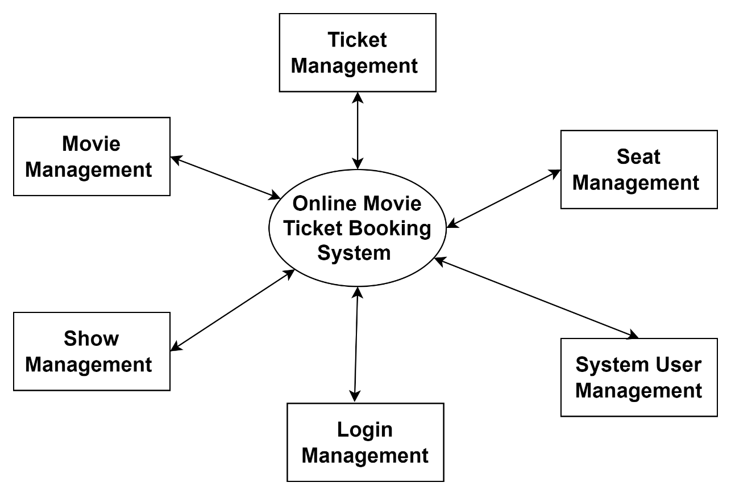

## FIRST LEVEL DATA FLOW DAIGRAM

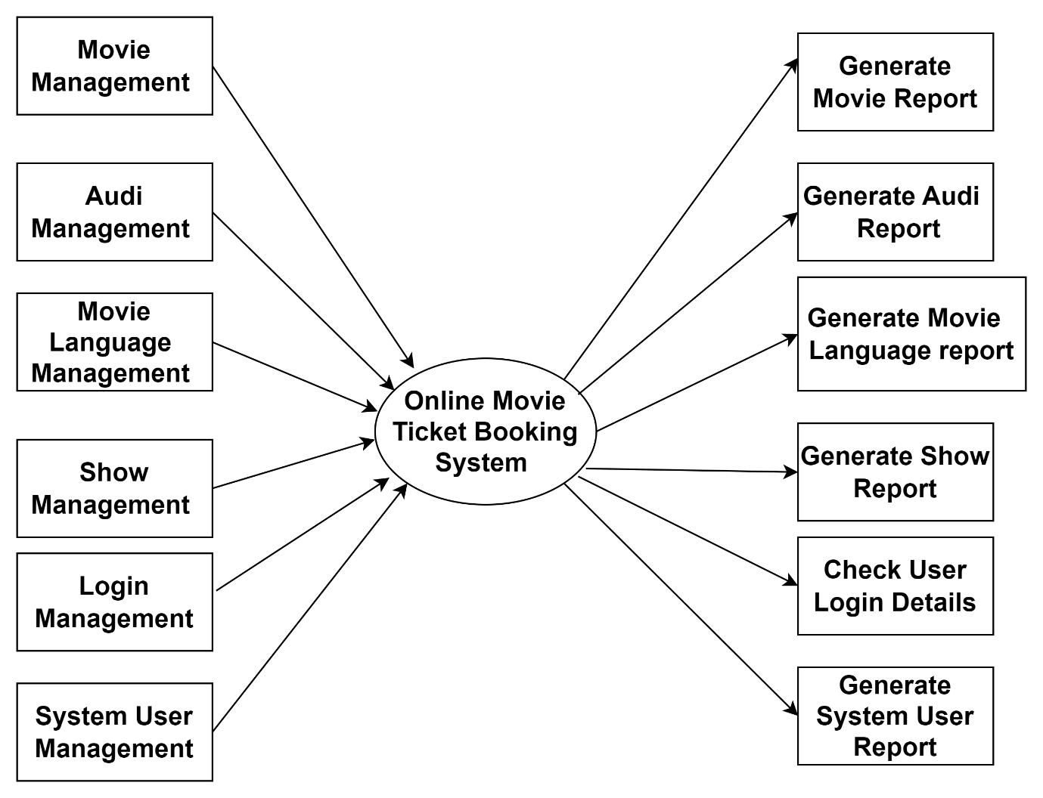

**SECOND LEVEL DATA FLOW DAIGRAM**

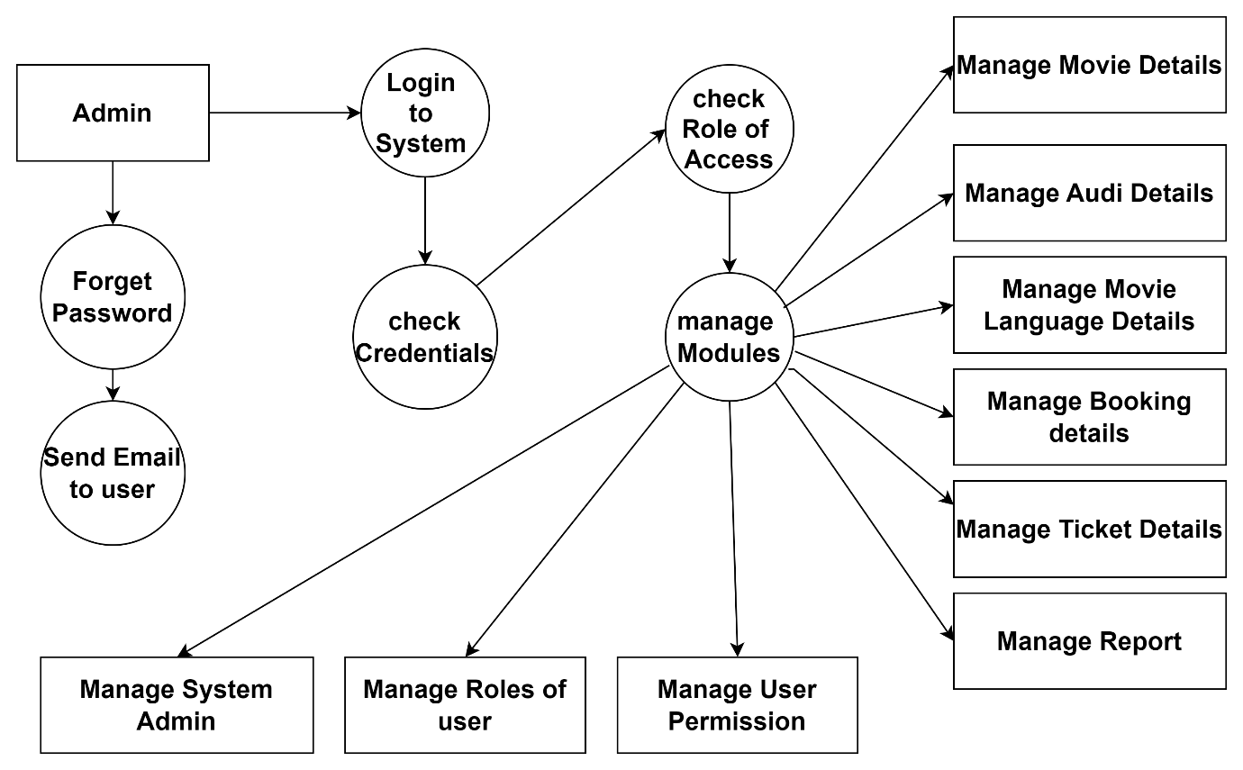

**5.3 DATA DICTIONARY**

Data dictionary is a repository that contains description of all the data objects consumed by the webapp application. It is a list of names used by the system alphabetically.

As well as the name, the dictionary should include a description of the named entity and, if the name represents of a composite object, there may be description of the name entity. Other information such as the date of creation, creator and the representation. Entity may also include depending on the type of module, which is being developed.

The data dictionary software can check for name uniqueness and tell requirements analyst duplication.

It serves as store of organizational information which can link analysis, design, implementation and evolution. As the system is developed, information is taken to inform the development. New information is added in it. All information about entity is in one place.

**DATA REPORTS :**

TABLE: **USER REGISTRATION**

|  |  |  |  |  |
| --- | --- | --- | --- | --- |
| Field Name | Datatype | Size | Constraints | Description |
| Id | Int | Auto (10) | Primary Key | Users id |
| Username | varchar | 100 | Not Null | Users name |
| Email | varchar | 100 | Not Null | Users email id |
| Password | Number | 100 | Not Null | Users password |
| Confirm Passsword | Number | 100 | Not Null | Users Confirm Password |
| Created at | Date & Time | 00 | Not Null | Current Regisration Time |

TABLE: **USER LOGIN**

|  |  |  |  |  |
| --- | --- | --- | --- | --- |
| Field Name | Datatype | Size | Constraints | Description |
| Id | Int | 100 | PrimaryKey | Stores id |
| Username | varchar | 100 | Not Null | User Resgiterd Name |
| Password | Number | 100 | Not Null | User Resgiterd password |

TABLE: **BOOK A TEST**

|  |  |  |  |  |
| --- | --- | --- | --- | --- |
| Field Name | Datatype | Size | Constraints | Description |
| Examiner ID | Int | 100 | Primary Key | Examiner Id |
| Full Name | varchar | 200 | Not Null | Examiner Name |
| Email | Varchar | 100 | Not Null | Examiner Email id |
| Phone Number | Number | 10 | Not Null | Examiner Number |
| Address | Varchar | 200 | Not Null | Examiner Address |
| Gender | varchar | 00 | Not Null | Examiner Gender |
| Student Type | Varchar | 00 | Not Null | Student Type |
| Exam Date | Date & time | 00 | Not Null | Time |

## Screenshots

Home Page :-

**7.ADVANTAGES AND** **LIMITATIONS**

**ADVANTAGES:**

**Convenience:** The biggest advantage of a movie ticket booking website is the convenience it offers to users. Customers can easily book tickets for their favorite movies from the comfort of their own homes, without having to stand in long queues at the cinema.

**Time-saving:** Booking tickets online saves time and effort for customers. They can easily select their preferred movie, show timings, and seats with justa few clicks.

**Availability:** Booking tickets online allows customers to view the availability of seats for different movies and shows. This helps them to plan their movie-going experience accordingly and choose a convenient time.

**Discounts and offers:** Many movie ticket booking websites offer discounts and special offers to their customers. This helps customers to save money on their movie tickets and encourages them to book online.

**Multiple payment options:** Movie ticket booking websites offer multiple payment options to customers, including credit and debit cards, net banking, and e-wallets. This makes it easy for customers to pay for their tickets using their preferred mode of payment.

**Disadvantages:**

**Technical glitches:** Movie ticket booking websites are prone to technical glitches, which can cause inconvenience to customers. Technical issues like slow loading, website crashes, and payment failures can discourage customers from using the website.

**Hidden fees:** Some movie ticket booking websites charge hidden fees, which are not clearly mentioned on the website. This can lead to confusion and frustration for customers.

**Limited seats:** Online booking of movie tickets can be problematic if a particular show or movie is highly in demand. In such cases, customers may not be able to book their preferred seats or may have to settle for suboptimal seats.

**No refund policy:** Some movie ticket booking websites do not have a clear refund policy, which can be a major issue for customers who need to cancel their tickets due to unforeseen circumstances.

**Security concerns:** Online ticket booking requires customers to enter their personal and financial details, which can pose a security risk. Customers need to be careful while sharing their sensitive information online and ensure that the website they are using is secure and reliable.

8.FUTURE ENHANCEMENT

The system is designed in such a way that addition of new modules can be done in a very simple and efficient manner.

The future holds a lot to offer to the development and refinement of this project. As proper documentation exists the whole system flow is traceable.

Some likely enhancements could be added in the future to enhance the capability of this system.

We may conclude that this software created will definitely find a good market in the

“MOVIE TICKET BOOKING.” to its maximum extend.

# **9.BIBLIOGRAPHY**

**WEB REFERENCE :**

[www.google.co](http://www.google.co)[m](http://www.google.com/)

[www.youtube.co](http://www.youtube.co)[m](http://www.youtube.com/)

www.openai.com

www.github.com